SYNOPSIS

Report on

Smart Erase
AI Image Background Remove

by
Ayush Saini (202410116100046)
Ashish Yadav (202410116100041)
Ashutosh Singh (202410116100043)
Session:2024-2025 (III Semester)

Under the supervision of

Mr. Roshan Kumar Gupta

KIET Group of Institutions, Delhi-NCR, Ghaziabad



Department Of Computer Applications
KIET GROUP OF INSTITUTIONS, DELHI-NCR, GHAZIABAD-201206
( 2025-2026 (III Semester)

ABSTRACT

The AI-Powered Image Background Removal System is a modern and efficient solution to a widespread challenge in digital media, e-commerce, and graphic design: accurately extracting the foreground subject from its background. Traditional background removal techniques — manual editing, masking tools, or chroma-keying — are slow, require expertise, and often produce inconsistent results. The proposed system leverages artificial intelligence (AI), machine learning, and a full-stack MERN architecture to deliver a fast, accurate, and fully automated background removal workflow.
At the core of the system is a Node.js-based AI processing service, integrated with a Python-backed image segmentation module that uses deep learning-based background detection and matting techniques. The system identifies the primary subject in the image, generates a clean alpha matte, and isolates the foreground with high precision. The processed output is delivered as a transparent PNG or with a custom background, offering professional-quality results with minimal user input.
The backend — developed using Node.js and Express.js — manages API endpoints, file uploads, authentication, and secure communication between the AI engine and the frontend. All image data, logs, and history are stored in MongoDB, enabling efficient retrieval, organization, and scalability. The frontend, built using React.js, offers a user-friendly interface for uploading images, previewing processed results, applying custom backgrounds, and downloading outputs instantly.
Key benefits of the system include high accuracy, drastic reduction in manual editing time, batch processing support, and scalability for industries such as online retail, advertising, media production, and digital marketing. By integrating AI-driven background removal with the MERN Stack, the system supports modern digital transformation and enhances creative workflows.
Keywords: Background Removal, MERN Stack, AI, Deep Learning, React.js, Node.js, Express.js, MongoDB, Computer Vision.

TABLE OF CONTENTS

Page Number
- Introduction 4-7
- Literature Review 8-9
- Project Objective 10-11
- Hardware and Software Requirements 12
- Project Flow 13-14
- Project Outcome 15-16
- Proposed Time Duration 17
References 18

INTRODUCTION

Image background removal has become an important requirement in many fields such as e-commerce, media production, digital marketing, photography, education, and graphic design. Removing the background helps highlight the main subject of an image, improves visual quality, and prepares images for professional use. For businesses, especially e-commerce platforms, clean product images directly influence customer trust and sales. Designers and content creators also depend on background-removed images for posters, advertisements, and creative editing.
Despite its wide importance, background removal is still performed manually in many places using tools like Photoshop or mobile apps. This manual process is slow, requires skill, and often produces inconsistent results. For institutions or companies that handle large numbers of images, manual editing becomes inefficient, time-consuming, and costly. Traditional methods also increase the chances of errors, uneven edges, or low-quality outputs.
These challenges highlight the need for an automated, intelligent, and easy-to-use system that can remove image backgrounds quickly and accurately. An AI-based background removal system solves this problem by using machine learning and image segmentation models to detect the main subject and remove the background automatically. When combined with modern web technologies like the MERN stack (MongoDB, Express.js, React.js, Node.js), the system becomes easy to use, scalable, and accessible through a simple web interface.
This project aims to replace manual editing with an automated AI-powered tool that delivers fast, precise, and high-quality background removal, making the process more efficient and reliable for modern digital workflows.

1. Problem with Traditional Methods
In many industries such as e-commerce, graphic design, advertising, and photography, background removal is still done manually using tools like Photoshop, mobile apps, or green screens. Although these methods have been used for years, they come with several major drawbacks:
• Time Consumption
Manually removing the background from a single image can take several minutes. For businesses handling hundreds or thousands of product images, this results in huge time loss and slow workflow.
• Human Error
In manual editing, mistakes such as uneven edges, missing details (like hair strands), or incorrect cut-outs are common, especially when the editor is rushed.
• Inconsistent Quality
Different editors produce different results, leading to image inconsistency — which is a serious problem for brand identity and professional design.
• High Cost for Bulk Editing
Companies often need to hire designers or outsource work, increasing costs significantly for large-scale editing.
• Lack of Automation
Manual tools cannot provide real-time processing, analytics, or bulk automation, making them ineffective for modern digital workflows.
These drawbacks make traditional background removal inefficient, expensive, and unsuitable for fast-paced industries.

2. Need for Automation
With rapid growth in Artificial Intelligence (AI) and computer vision, automated background removal has become a powerful alternative to manual editing. Automation brings several advantages:
• Efficiency
Background removal can be done in seconds instead of minutes, drastically improving workflow speed.
• High Accuracy
AI models detect edges, hair, and fine details much better than manual tools, providing cleaner and more professional cutouts.
• Cost-Effective
Organizations can process hundreds of images without requiring additional manpower.
• Secure Storage
Using databases such as MongoDB, images and processed results can be safely stored and retrieved instantly.
• Real-Time Processing
Dashboards can instantly display uploaded images, processed outputs, and usage analytics.
• Integration Capabilities
AI background removal can be integrated into e-commerce platforms, design tools, mobile apps, and content creation pipelines. Post-pandemic, the demand for digital workflows has increased, making automated AI tools more valuable than ever.

3. Proposed Solution
The AI Image Background Removal System combines deep learning–based image segmentation with a modern MERN (MongoDB, Express.js, React.js, Node.js) architecture to deliver a fast, accurate, and scalable solution.
It consists of three main modules:
1. Node.js + Express Backend
Responsible for:
- Handling API requests
- Communicating with the Python AI module
- Managing user authentication using JWT
- Storing image data and logs in MongoDB
- Providing secure access for frontend operations
The backend ensures smooth workflow, security, and connectivity across the system.
2. Frontend Dashboard (React.js)
Built using React.js, GSAP animations, and HTML/CSS, the dashboard allows users to:
- Upload images
- Preview background-removed outputs
- Download final results
- View history and records
- Access usage analytics
LITERATURE REVIEW
AI-Based Background Removal Technologies
Background removal has significantly improved with advancements in artificial intelligence, especially deep learning and computer vision. Early background removal methods depended on manual tools or traditional image processing techniques such as color thresholding, chroma keying (green screen), or edge detection. However, these approaches performed poorly with complex backgrounds, varying lighting conditions, and fine details such as hair, shadows, or semi-transparent objects.
Modern AI-driven segmentation models have transformed the field by enabling pixel-level accuracy. Several studies and technologies contribute to today's background removal systems:
1.Role of Backend in AI Systems
While the AI module handles image recognition, the backend is responsible for secure data storage, authentication, report generation, and user management.

- Spring Boot is a Java-based framework known for its speed, modularity, and ease of integration with RESTful APIs.
- Johnson et al. (2018) highlight that decoupling the AI recognition logic (Python) from the core backend (Java) improves scalability and maintainability. This approach allows each module to be independently developed, tested, and deployed — a microservices-friendly architecture.

- The backend ensures role-based access control (RBAC), enabling different functionalities for admins, teachers, and students.

  - Case Studies

- FaceX in Indian Schools:
An AI-based attendance solution deployed in multiple Indian schools reduced attendance-taking time by 85% and eliminated proxy marking. Teachers reported a more efficient start to classes, and administrators benefited from instant reporting.
- Microsoft Face API in Corporate Training:
Deployed in multinational corporations, the Microsoft Face API-based attendance system improved reporting accuracy by 98% and allowed HR departments to link attendance directly to payroll systems.
These examples validate the practical benefits of automated attendance solutions and demonstrate scalability across both educational and professional domains.

  - Security Considerations
The handling of facial data demands stringent privacy and security protocols.

- OWASP guidelines recommend implementing secure authentication (JWT), encrypted data transmission (HTTPS), and strict access controls.

- Data privacy laws, such as the GDPR (General Data Protection Regulation) and the Personal Data Protection (PDP) Bill in India, require that biometric data be collected and stored only with explicit consent and used solely for its intended purpose.

- Best practices also include limiting data retention periods, hashing embeddings instead of storing raw images, and implementing intrusion detection systems to safeguard servers.

PROJECT OBJECTIVE
The primary objective of this project is to develop an AI-based Image Background Removal System that can automatically detect and separate the foreground object from its background with high accuracy, speed, and consistency. The system aims to eliminate the need for manual editing and provide a fully automated solution suitable for industries such as e-commerce, digital media, and graphic design.
Automation of Background Removal
A key objective is to automate the entire background removal process using machine learning and computer vision techniques. The system should be capable of processing images without human intervention, reducing manual effort, and improving workflow efficiency.
High Accuracy and Precision
Another important objective is to achieve high accuracy in identifying object boundaries, including complex areas such as hair, fabric edges, and shadows. The system should produce clean, professional-quality outputs that match or exceed manual editing standards.
User-Friendly Interface
The project aims to provide a simple and intuitive interface that allows users to upload images, preview results, apply custom backgrounds, and download the final output. The interface should support smooth interaction and require minimal technical knowledge.
Scalability and Performance
The system should be designed to handle large numbers of images efficiently. This includes supporting batch processing, real-time previews, and fast response times. The backend architecture should be scalable to meet the demands of businesses and web applications.

Integration Capability
Another objective is to enable easy integration with web applications, e-commerce platforms, and mobile apps. By developing the system using a MERN-based architecture, the project ensures compatibility with modern development environments and third-party services.
Secure Storage and Data Handling
The objective also includes implementing secure handling and storage of images. The system should store processed and uploaded images in a managed database and ensure safe retrieval and usage through proper authentication and access control.
Improved Productivity
Finally, the project aims to significantly improve productivity by reducing the time, cost, and effort associated with manual background removal. By automating the process, users can generate high-quality results quickly and focus on other creative or operational tasks.

HARDWARE AND SOFTWARE REQUIREMENTS
Hardware Requirements
To ensure smooth operation of the AI Image Background Removal System, the following hardware components are recommended:
Processor: A minimum of Intel i5 or above is recommended for efficient processing.
RAM: At least 8 GB of RAM is required, but 16 GB is preferred for handling multiple images and faster AI processing.
Storage: A minimum of 256 GB of storage is needed. SSD storage is preferred for faster image processing and system performance.
Graphics Support: A system with GPU acceleration (such as NVIDIA graphics) is beneficial when running AI models that require deep learning computations.
Display: A standard HD or Full HD monitor for better visualization of processed images.
Input Devices: Keyboard, mouse, and other standard peripherals.
Software Requirements
The software stack required for developing and running the project is as follows:
Operating System: Windows 10/11, Linux, or macOS.
Programming Languages: JavaScript (Node.js and React.js) and Python for AI processing.
Backend Framework: Node.js with Express.js for handling API requests and server-side logic.
Frontend Framework: React.js for building the user interface.
Database: MongoDB for storing user data, image records, and logs.

PROJECT METHODOLOGY
Introduction to Methodology
The project methodology outlines the step-by-step process used to design, develop, and implement the AI Image Background Removal System. This methodology ensures that the system is accurate, efficient, scalable, and easy to use. The approach combines AI-based image processing with a MERN stack architecture for smooth integration and execution.
Data Collection and Preprocessing
The first step involves collecting sample images to understand different background patterns, lighting conditions, and object shapes. These images help in testing and validating the AI module. Preprocessing steps such as resizing, noise reduction, and normalization are applied to ensure that the images are suitable for background removal.
AI Model Integration
The system uses a deep learning-based segmentation module to detect and separate the foreground from the background. The AI model processes the input image, identifies object boundaries, and generates an alpha matte. This alpha matte is used to produce transparent or custom-background images. The model is integrated with the backend through APIs to ensure seamless communication.
Backend Development
The backend is developed using Node.js and Express.js. It handles image uploads, routes requests to the AI module, processes responses, and stores image metadata in a database. The backend also manages authentication, file handling, and communication between the frontend and AI model. MongoDB is used to store processed images, logs, and user data in an organized manner.

Frontend Development
The frontend is built using React.js to provide a user-friendly interface. It allows users to upload images, preview the processed output, apply custom backgrounds, and download the final result. The interface supports drag-and-drop functionality and displays results in real time for a smooth user experience.
Testing and Quality Assurance
After development, the system undergoes functional testing, performance testing, and user experience testing. This ensures that the AI model removes backgrounds accurately, the interface is easy to use, and the entire system operates efficiently. Issues identified during testing are fixed to improve stability and reliability.
Deployment and Integration
Once testing is complete, the system is deployed on a suitable hosting platform. The MERN stack allows easy deployment on cloud servers, making the application accessible through a browser. The system can also be integrated with e-commerce platforms, design tools, or business websites depending on user requirements.
Maintenance and Updates
Continual maintenance ensures that the system remains functional and up to date. Updates may include improving AI accuracy, adding new features, enhancing UI/UX, or integrating new tools. Regular monitoring helps identify errors and optimize performance.

PROJECT OUTCOME
Successful Automation of Background Removal
The project successfully delivers an automated system that removes image backgrounds quickly and accurately. By integrating AI-based segmentation with a MERN architecture, the system eliminates the need for manual editing and significantly improves workflow efficiency.
High-Quality Foreground Extraction
The system is capable of producing clean and precise foreground extraction, even in challenging areas such as hair, edges, shadows, or semi-transparent objects. This ensures professional-quality output suitable for e-commerce, marketing, photography, and media production.
User-Friendly Web Interface
A functional web-based interface allows users to upload images, view real-time previews, apply custom backgrounds, and download final results. The interface is simple, intuitive, and designed for users with minimal technical knowledge.
Fast Processing and Improved Performance
The integration of AI processing ensures quick background removal, reducing the time required to process images. The system supports efficient execution and handles multiple images without performance issues.
Scalable Architecture
With the MERN stack, the project demonstrates scalability and flexibility. The architecture can be expanded to support more users, additional features, and batch processing capabilities, making it suitable for commercial deployment.

Secure Data Handling and Storage
The project ensures safe handling of all uploaded and processed images. By using MongoDB and secure backend routing, the system maintains data integrity and protects user information.
Enhanced Productivity for Users and Businesses
By automating a previously time-consuming task, the system significantly increases productivity for designers, online retailers, media creators, and businesses that rely on visual content. Users can now focus more on creativity and production rather than manual editing.
Foundation for Future Enhancements
The outcome of the project provides a strong foundation for future improvements, such as adding object detection, background editing tools, color correction, AI-powered enhancement, and full batch automation. The system can be extended to mobile applications or integrated into existing business platforms.

PROPOSED TIME DURATION
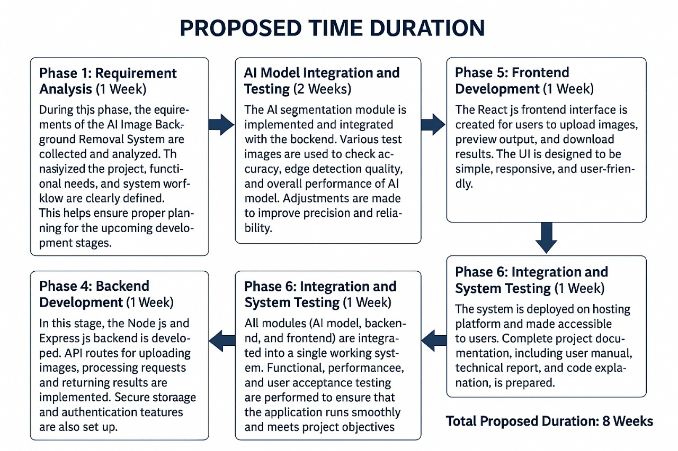

REFERENCES

- Bradski, G. and Kaehler, A. "Learning OpenCV: Computer Vision with the OpenCV Library." O’Reilly Media, 2008.
- He, K., Zhang, X., Ren, S., and Sun, J. "Deep Residual Learning for Image Recognition." IEEE Conference on Computer Vision and Pattern Recognition (CVPR), 2016.
- OpenCV Official Documentation. Available at: https://docs.opencv.org/
- MongoDB Documentation. Available at: https://www.mongodb.com/docs/
- React.js Documentation. Available at: https://react.dev/
- Node.js Documentation. Available at: https://nodejs.org/en/docs/
- Kingma, D. and Ba, J. "Adam: A Method for Stochastic Optimization." arXiv preprint arXiv:1412.6980, 2014.
- Xu, N., et al. “Deep Image Matting.” IEEE Conference on Computer Vision and Pattern Recognition (CVPR), 2017.
- Goodfellow, I., Bengio, Y., and Courville, A. "Deep Learning." MIT Press, 2016.

